Membership & Engagement Officer (fixed-term contract)

Post | Membership & Engagement Officer (fixed-term contract)
Location | Office-based, Edinburgh with the potential for some home working.  Travel throughout the country will also be required.
Salary | £37,383 - £39,371 pro rata + pension (currently 11.5% employer contribution). Our expectation is to appoint at the entry level of the salary scale unless there are exceptional circumstances.
Length of contract | Fixed term to December 2025
Hours | Our preference is full-time, 35 hours per week (excluding meal breaks), however we can consider part-time, either as 28 hours (four days) per week or as a job share.  Please provide an indication of your preferred working hours in your cover letter.
Leave entitlement | 25 days p/a, plus 10 public holidays
Probationary period | 3 months
Closing Date | Monday 18th November 2024 at 12noon
Interviews | Interviews will be held on Monday 25th and Tuesday 26th November 2024

Purpose of post:

We are looking for a dynamic and committed individual to provide advice and information to communities on their journey towards setting up development trusts. Working as part of the Development Officers’ team, the postholder will provide a key role in delivering a support service to aspiring development trusts. The postholder will also contribute to the development of DTAS member and aspiring member resources and communications.

This opportunity has arisen due to an internal secondment within DTAS and is for a fixed-term to December 2025.

Summary of main tasks

Deliver Aspiring Membership Support Service:
- Deliver an information, advice and support service to communities looking to become development trusts
- Make presentations and deliver training to community groups, intermediaries and local authorities
- Respond to enquiries, as appropriate
- Provide more intensive support when required, particularly on appropriate governance arrangements and community engagement
- Signpost to other resources, agencies and support programmes
- Attend and contribute to relevant community meetings and events
- Arrange learning / study visits to other development trusts
- Assist organisations to meet DTAS membership criteria
- Maintain up-to-date and accurate records within DTAS information systems and update the DTAS database

Support development of resources and communications:
- Work with the Development Officer team to develop information, resources and promotional materials for members and aspiring members
- Support the Development Officer team to update social media content and the DTAS website
- Coordinate the production of the DTAS newsletter and other member mailings
- Support the delivery of the DTAS annual conference
- Contribute to the work of the Development Officer team as appropriate
- Carry out other duties relevant to the post

Please note that the post-holder is required to travel throughout the country and as such, hold a full driving licence. There is evening work on a fairly regular basis, with occasional overnight stays and weekend work. No overtime paid, but time off in lieu may be taken as appropriate.

Person Specification

Skills & experience
You will have
- Experience of working with communities and an understanding of grassroots community-led approaches to regeneration
- Experience of providing advice and support to individuals and organisations, ideally in a community context
- Knowledge of organisational governance
- Experience of delivering training or providing information in a public setting and online
- Skilled in producing written communication across different platforms and for diverse audiences
- Experience of community development, community enterprise and community ownership (desirable)
- Experience / knowledge of community consultation (desirable)

Personal attributes
You will be:
- Strongly committed to development trusts, community-led regeneration and placemaking
- Friendly, approachable and an effective communicator
- Highly organised with excellent attention to detail
- Able to manage a varied and busy workload
- A problem-solver, able to use initiative and be proactive
- Digitally confident, skilled in using IT systems, software and databases
- Able to work flexible hours when required (including some evenings and weekends) to meet the needs of organisation
Benefits
- On-the-job training and relevant formal training
- 25 days of annual leave, plus 10 days of public holidays (pro rata for part-time employees) and an additional 3 days of fixed leave during Christmas
- DTAS pension scheme with an employer contribution of 11.5%
- Employee wellbeing group with all-staff activities, plus a personal wellbeing budget
- Flexible working

To Apply for the Post:

If you are keen to be considered for this opportunity, please email kay@dtascot.og.uk with your CV and a covering letter detailing your reasons for applying and specific experience to match the criteria above by no later than 12noon on Monday 18th November 2024.

Interviews will be held on Monday 25th and Tuesday 26th November 2024. These will be in person in our Edinburgh office but we can consider requests for Zoom interviews if required. Please confirm your preference in your covering letter.

If you have any questions regarding your application, or would like an informal conversation, please contact Felix Spittal, felix@dtascot.org.uk, Head of Member Support.

DTAS is committed to a policy of equality & diversity. We take the collection and use of your data seriously, please see link to the DTAS Recruitment Privacy Statement

This position is funded by:
 | 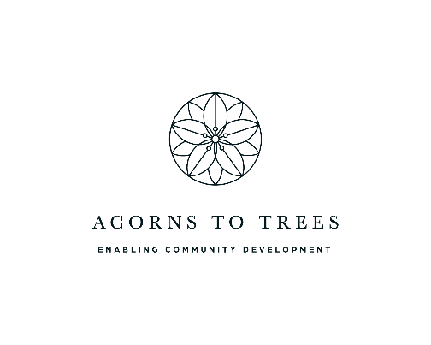

Background information:

Development Trusts Association Scotland (DTAS) is an independent, member-led organisation which aims to promote, support and represent development trusts in Scotland. Established in 2003, DTA Scotland now has over 350 development trust members, which makes it one of Scotland’s largest and most dynamic community-led networks. Our office is based in the Dalry area of Edinburgh, a short walk from Haymarket Station.

A development trust is a community-owned and led organisation. They aim to create social, economic and environmental renewal in a defined geographical area, creating wealth within that area and keeping it there. They are diverse in nature: large and small, rural, and urban, mainland and island based.

DTAS provides information, advice and support, and facilitates our development trust network. We run an annual conference, produce publications and resources, and provide a suite of peer-to-peer learning, training and support interventions. We also operate our Community Ownership Support Service which supports the transfer of public assets to community organisations and Democratic Finance Scotland, a programme of support for community and social enterprises to consider alternative methods of raising finance.

